1. Design a two page Web site with the following requirements:
2. The first page (page1.html) has a link to the second page (page2.html) and vice versa. This can be done using anchors.
3. The first line of each page is written as a heading element.
4. Use embedded style sheet to set IMAGE.jpg as a background in page1.html. The background shall be positioned to the right and repeated vertically.
5. An external CSS shall be used to set the font of all paragraphs to Arial purple. Define two paragraphs in each file.
6. Add a third paragraph in page1.html that contains text in bold navy with font of size 30pt.
7. Write your name and ID in a fourth paragraph in page1.html.
8. Use class Selector to set the direction of the first paragraph of page2.html to be right to left and the second paragraph to be centered.

Source Code:

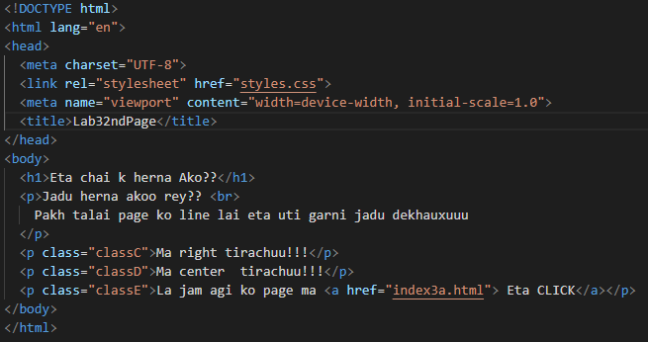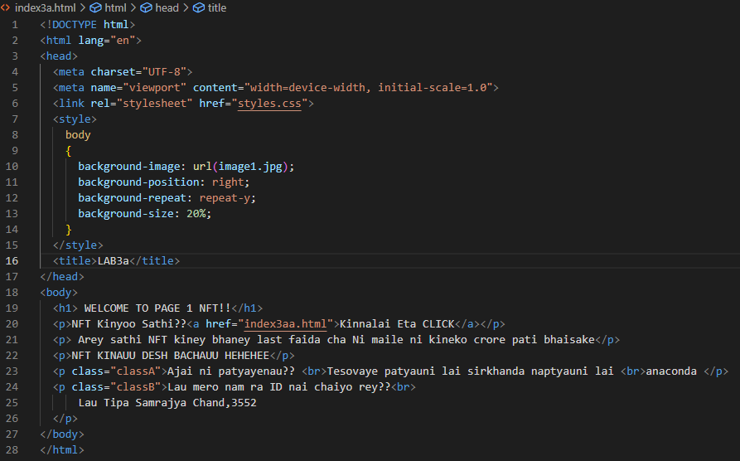

OUTPUT:

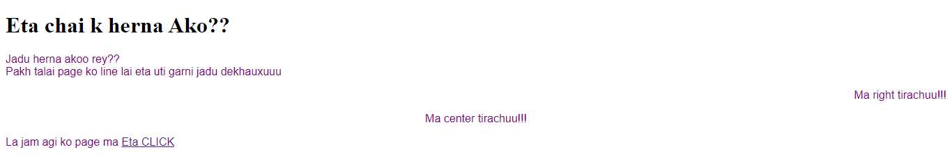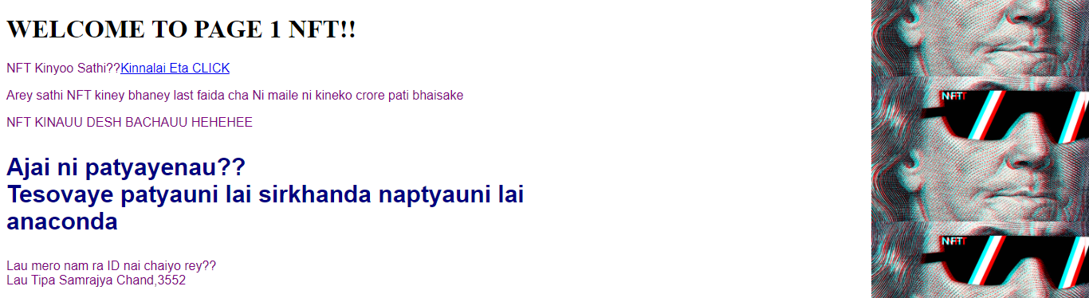

2. You are given an incomplete multi-page website about butterflies. You are expected to do the following in order to complete it:

1. Add a thick border to h1 elements with a color of your choice.
2. Create “Art and Culture” page. It should include unordered list with image bullets of your choice.
3. Apply different border styles to butterflies “Fast Facts” similar to the sample page.
4. Add a link in the drop-down menu to the “References” page. The page shall include Wikipedia link reference: http://en.wikipedia.org/wiki/Butterfly. Use distinctive styles for the link, visited link, and when rolling over the link. You can utilize color, text-decoration, and background-color properties to achieve that.

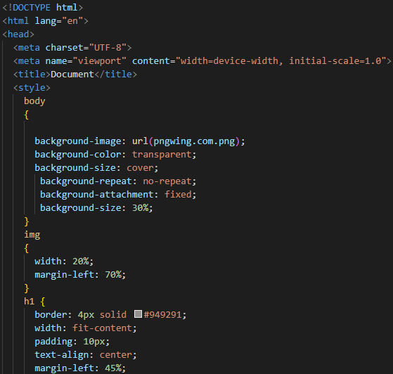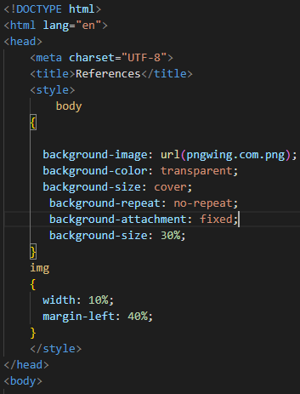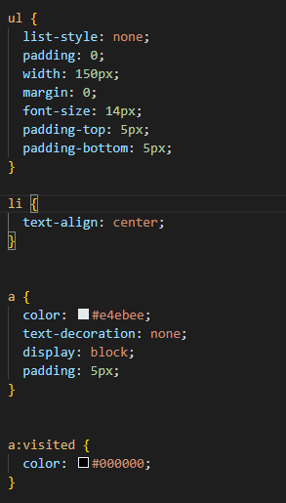SOURCE CODE:

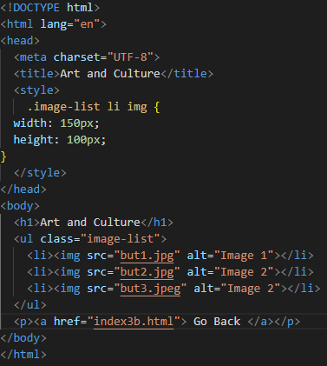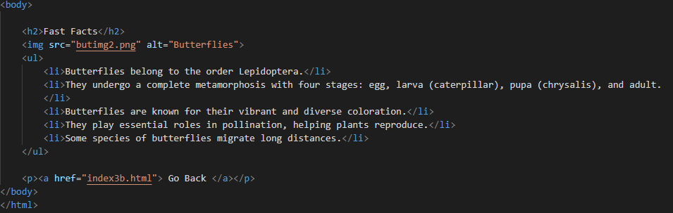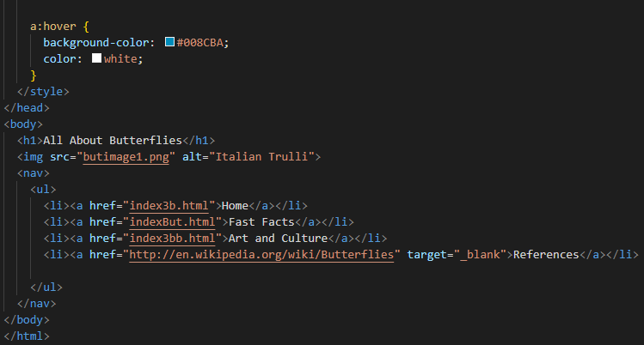

OUTPUT

